Scenario Analysis
In business as in life, the only thing that’s certain is uncertainty. Scenario analysis is a powerful process for navigating the uncertainty of the future by analyzing the potential business impacts of future events and considering alternative possible outcomes. Companies can use scenario analysis to explore a broad range of possible future situations, from economic slowdowns and natural disasters to expanding a product line or opening new offices.

What Is Scenario Analysis?
Scenario analysis is a technique that provides a rational and structured way to analyze the future. Businesses can use it to examine different potential impacts of negative and positive events, such as:
- What are the possible impacts on the business of an economic slowdown?
- What happens to revenue and profitability if the cost of various raw materials rises?
- What revenues might be generated by a new product line?
- How would the business be impacted by the unexpected market entry of new competitors?
Scenario analysis doesn’t attempt to predict a single outcome from any of these events. Instead, it examines a spectrum of different potential situations and outcomes, typically ranging from a best-case to worst-case scenario. Businesses can then conduct scenario planning to better prepare for these events and their potential impacts.
Scenario analysis is not new. It was pioneered by the US military during the mid-1900s, and Shell Oil started using it during the 1970s to analyze and respond to fluctuations in global oil supplies. It’s now widely used by businesses, thanks in part to financial modeling tools that eliminate much of the manual effort and make the process much faster. It may be even more important for small businesses than for larger ones, since smaller companies may be more heavily impacted by a single event. Scenario analysis is employed by financial services companies to analyze risks and make investment decisions, and it can even be used to analyze household finances.

Scenario Analysis
When it comes to managing multiple project and product portfolios, making the right decisions is critical for companies to succeed. In today’s uncertain business environment, organizations need tools like Scenario Analysis to help them foresee possible outcomes and make informed choices.
Scenario analysis is certainly one of the most effective tools for planning your organization’s roadmap in advance. In this guide, we will explain in detail what Scenario Analysis is, how it works, its different use cases and the best software to use this technique.
Types of Scenarios
One key benefit of effective scenario analysis is that it drives decision-makers to consider a range of potential situations, each with its own set of assumptions. This can help prevent businesses from becoming fixated on a single, overoptimistic view of the future and developing business plans that assume ideal conditions and outcomes. In addition to the common best- and worst-case framework, there are several distinct types of scenarios that organizations can explore, each serving a different purpose:

Normative scenarios are built around the most likely or expected outcomes, grounded in current trends and known variables. These help businesses align their plans with what seems most probable so they can allocate their resources appropriately. Normative scenarios can be thought of as a broader, more exploratory kind of forecast.
Extreme or edge case scenarios examine unlikely but potentially high-impact events. Also known as “black swan” scenarios, these are not expected to occur, but exploring them helps organizations test their resilience and better prepare for the unexpected.
Scenario analysis can also be categorized by whether the focus is on internal or external factors:

Internal scenarios concentrate on elements within the company’s control, such as operational improvements, staffing changes, or product development initiatives.
External scenarios address outside factors, such as shifts in consumer behavior, regulatory changes, competitive actions, or macroeconomic conditions.
Scenarios can differ based on time horizon:

Short-term scenarios tend to look ahead one or two years. They are useful for tactical decisions and immediate risk management.
Long-term scenarios often span five to 10 years or more. They are geared toward big-picture changes, such as new technologies or demographic shifts.
It’s a good idea to incorporate a mix of these scenario types to improve the quality of strategic thinking, since the goal of scenario analysis isn’t to predict the future with certainty but to prepare for a range of possibilities For example, a common application of scenario planning—a new product launch—would likely combine short-term scenarios for the initial launch, with long-term scenarios for market adoption, scalability, and profitability.
Cases in Scenario Analysis
A scenario analysis generally considers at least three types of scenarios:
Base-case scenario: A baseline scenario based on current, commonly accepted assumptions.
Worst-case scenario: The most negative set of assumptions.
Best-case scenario: The ideal projected scenario to achieve goals and objectives.
For example, in Kooky Cooks’ best-case scenario, revenues might actually rise because people stay at home and do more cooking instead of eating out. In the worst-case scenario, demand falls while all costs rise. In the base case, current trends continue into the future. Each of these scenarios has a different impact on revenue and profit.
Examining a range of scenarios provides the company with a range of possible outcomes for planning purposes. For example, the best-case scenario might result in a net profit margin of 20%, while the worst-case scenario results in a margin of 5%. The company uses the range of 5%-20% to guide its decisions about investing in the manufacture of new products.

A company may also assign probabilities to each scenario, based on its assessment of the likelihood that it will occur. This can help to guide the company’s subsequent planning and decisions about how to allocate resources.
Multiple scenario analysis: Scenario analysis doesn’t have to be restricted to just three possible cases. A company may consider many different scenarios, each using a different set of assumptions. The trade-off is that more scenarios require more effort to analyze them.
Components of Scenario Analysis
Effective scenario analysis relies on four clearly defined components—key drivers, scenario case, time horizon, and scenario scope—that work together to clarify assumptions, set boundaries, and tailor analysis to specific business needs. Without them, the process is at risk of becoming vague, impractical thought exercises. The components also facilitate consistent comparisons across scenarios, making it easier to identify patterns and stress-test decisions.
Key drivers are the internal and external variables that most significantly influence outcomes. Examples include factors like production capacity and marketing spend or market demand and interest rates. The key drivers form the foundation of the scenario analysis, so it is vital to properly identify them. They are the inputs that get adjusted in different scenarios.
A scenario case provides the specific assumptions and conditions used for each analysis. Each case should be internally consistent, meaning the assumptions align with each other and are plausible. They should also be directly relevant to the decision at hand, excluding elements that are not core to the issue. Finally, the scenario case should be plausible.

Here is an example of a scenario case that contains all three of these characteristics: In response to new government incentives for renewable energy, a solar panel manufacturer sees a 25% increase in residential demand, triggering a decision to expand production capacity while navigating increased competition and supply chain pressures.
Time horizon defines how far into the future the scenario extends. The selected horizon should match the strategic context. For instance, a pharmaceutical company might use a 10-year outlook for research and development, while a retailer might use a one-year horizon for inventory planning.
Scenario scope sets the boundaries of what the analysis will cover, including the range of factors and the level of detail in the analysis. It should be broad enough to capture meaningful variables but focused enough to remain manageable. For example, a fast-food chain’s scenario scope would include factors like dietary trends and food prices by product category but might scope out office supply costs.

How to do a scenario analysis? A 10- step framework
And yes, conducting a scenario analysis is a time-consuming process. It is a process in which, in order to obtain useful and actionable outcomes, you need a well-structured approach in which nothing can be left to improvisation.
This is the 10-step process you need to follow so that your scenario analyses and simulations bring value to the business.
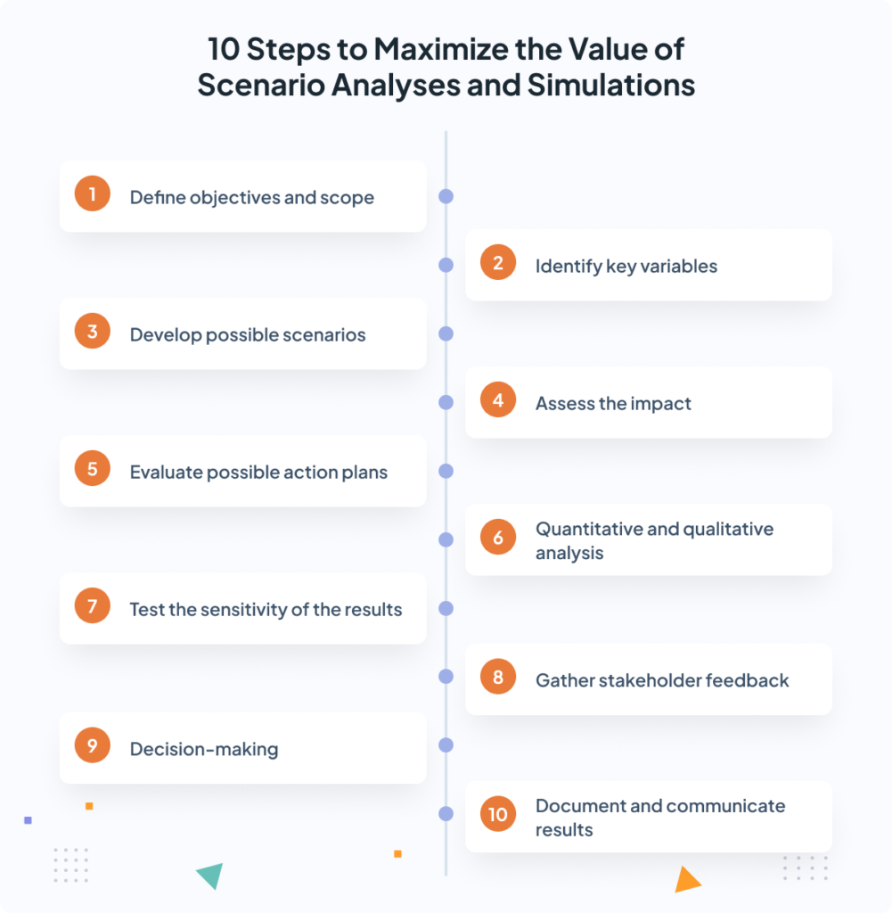

1. Define objectives and scope
Every scenario analysis should start with a clear definition of the objectives and scope. What are you really trying to analyze? Do you want to focus on resource allocation, or rather on financial management and project prioritization?
Defining the objective and scope of the analysis will give you a roadmap and prevent you from wasting time on irrelevant details. For example, if your goal is to evaluate how to redistribute resources among projects, you will need to focus on knowing the internal capacity, the expected timelines for each project and the organization’s strategic objectives.
Key points to consider:
- Focus on concrete objectives.
- Define a time horizon (quarterly, annual, etc.).
- Determine the critical factors (financial management, deadlines, resource allocation, etc.).

2. Identify key uncertainties and variables
Once you are clear on the objectives, the next step is to identify those key uncertainties and variables that may affect the outcome of the projects. In PPM, we can identify 2 types of variables:
- External: these include, among others, market conditions, economic changes or new regulations.
- Internal: budgetary restrictions, availability of resources, technological advances, etc.
Understanding the impact of each uncertainty is crucial, as they will be the basis for developing your scenario simulations.
Keys to keep in mind
- Prioritize uncertainties according to their likelihood and impact.
- Gather data to quantify these uncertainties.
- Involve stakeholders to help you identify these variables and their impact.

3. Develop a set of possible scenarios
Once the uncertainties have been identified, you should develop a set of scenarios that represent various possible futures, with each scenario addressing how the uncertainties evolve.
These scenarios should serve to test your strategic and operational plans. Here you should put some strategic creativity into practice and come up with at least 3 possible scenarios. For example:
- Best-case scenario: in this scenario, everything goes smoothly. Projects are delivered on time, there are no resource constraints, and the budget for each project hardly varies. This type of scenario will help you set ambitious goals and encourage creative thinking to exceed expectations.
- Worst-case scenario: In this scenario you will encounter a myriad of obstacles. If you prepare in advance for the worst-case scenario, you can then develop contingency plans to minimize the impact of each variable.
- Most likely scenario: this would be the most realistic scenario you can come up with, neither as optimistic nor as pessimistic as the previous ones. There will be difficulties, yes: some delays, some pressure with the budget, but in the end the projects will move forward, more or less.
Keys to keep in mind
- Create 3-5 scenarios to get the full picture.
- Make sure each scenario covers the major uncertainties.
- Scenarios should be realistic, and data driven.

4. Assess the impact
With the scenarios in place, you must now evaluate how well or poorly your project portfolios will perform. This assessment can be both quantitative (financial impact, resource costs) and qualitative (alignment with strategy, stakeholder opinion, etc.).
For example, let’s focus on a pessimistic scenario: what would happen if the organization had no key skills, or if the budget was reduced by 25%? Assessing these impacts will give you a clear idea of the challenges and opportunities that each scenario presents.
Key tips to keep in mind
- Evaluate both short-term and long-term impact.
- Use quantitative and qualitative metrics.
- Involve team leaders, project managers and other stakeholders to get a more complete picture.

5. Evaluate strategic options and contingency plans
Now that you have an idea of the impact of each variable on your organization, you will need to:
- Develop a strategic roadmap to take advantage of the opportunities of the most optimistic scenarios.
- Develop contingency plans to mitigate risks for the worst-case scenario.
For example, if the worst-case scenario includes resource reductions, you might design a plan to prioritize certain projects or delay the less important ones. Or if you encounter an ideal scenario, you could accelerate key projects or expand the portfolio to take advantage of the favorable timing and available resources.
Key takeaways
- Develop flexible strategies that you can adjust in case scenarios change.
- Prioritize actions based on their impact and feasibility.
- Always prepare contingency plans for the most unfavorable scenarios.

6. Quantitative and qualitative analysis
At this point, it is time to combine quantitative and qualitative analysis to get a more complete view of each scenario.
- Quantitative analysis may include resource planning, timeline projections or financial modeling of project portfolios.
- Qualitative analysis, on the other hand, involves assessing factors such as stakeholder engagement, team morale and the alignment of each project with strategy.
For example, in resource allocation, quantitative analysis would calculate the cost of resources, while qualitative analysis would look at the ability of teams to meet project demands under different conditions.
Key considerations
- Use historical data for quantitative analysis.
- Leverage stakeholder feedback for qualitative analysis.
- Seek a balance between data and real-world consequences.

7. Test the sensitivity of the results
Sensitivity analysis is key to understanding how small changes in certain variables can affect different scenarios. You have to adjust some factors, such as resource availability or project duration, to see how sensitive the results are to those changes.
For example, what would happen if a project is delayed by a month, or if the budget increases by 10%? Sensitivity analysis will help you identify which variables are really critical to your organization’s success and prepare better.
Key things to consider
- Identify the key drivers for each scenario.
- Test small changes to understand sensitivity.
- Adjust your strategic plans based on the results.

8. Engage stakeholders and review feedback
Scenario Simulation is not something that should be done by just one person. You must involve different stakeholders to ensure that the scenarios are realistic and that everyone is aligned.
For example, a Product Manager or IT Manager could provide operational details that you may not have initially considered, or executives and strategy managers could highlight strategic priorities that need to be integrated into the analysis.
Key things to consider
- Organize regular review sessions with stakeholders.
- Incorporate their feedback into the adjustments you make to the scenarios.
- Ensure that the scenario results are aligned with the organization’s strategy.

9. Make informed decisions
With all the information at your fingertips, you can now begin to make decisions on how to proceed. This might involve reprioritizing projects, reallocating staff and funds, or implementing contingency plans based on what each scenario simulation tells you.
For example, if in the most-likely scenario you conclude that key projects can be completed, you can move forward with minor adjustments. On the other hand, if the worst-case scenario is ultimately the most likely, you will need to cancel or delay some projects so as not to waste resources.
Key takeaways
- Base your decisions on data and feedback.
- Prioritize initiatives that offer more value with less risk.
- Be flexible to adapt to changing conditions in today’s business environment.

10. Document and communicate results
And finally, you must document everything and communicate the results to stakeholders. Use dashboards, tables, presentations and other resources to make information more accessible. Make sure everyone is aligned on the way forward and understands the steps needed to execute contingency plans if necessary.

Scenario Analysis techniques
When performing scenario analysis and simulations, you can use certain techniques to assess future uncertainties and make more informed decisions.
In our 10-step Scenario Analysis framework we have already highlighted two of these techniques: best-case, worst-case and sensitivity analysis. These are two of the most widespread techniques for simulating scenarios, but they are not the only ones. These are other techniques that you can put into practice in your Scenario Simulation processes:
- Monte Carlo Simulation: this is based on the use of probability distributions to simulate different possible scenarios. Basically, it allows you to visualize how likely it is that one scenario or another will occur and, from there, make decisions. It is especially useful in financial and risk analysis.
- Cross impact analysis: this technique focuses on how changes in one variable can affect others. It is very useful in complex environments with many project interdependencies, where any change in one project or resource can generate a domino effect.
- Decision trees: This is a visual representation of possible outcomes based on the decisions you make. Each branch of the tree shows a different path, with its respective risks and outcomes. It is a very useful technique for evaluating sequential decisions and comparing different strategic options.
- Scenario storytelling: this involves creating detailed descriptions of each scenario, mixing the qualitative with the quantitative. It is a very useful technique for departments with a less technical background to understand how each scenario would play out and prepare them for broader impacts, such as market trends or regulatory changes,
- Scenario Matrix: finally, with the Scenario Matrix you can compare different scenarios by plotting them on 2 axes, each representing a key variable. It is a quick and visual way to see how the scenarios relate to each other and to prioritize which ones to focus on for decision making.
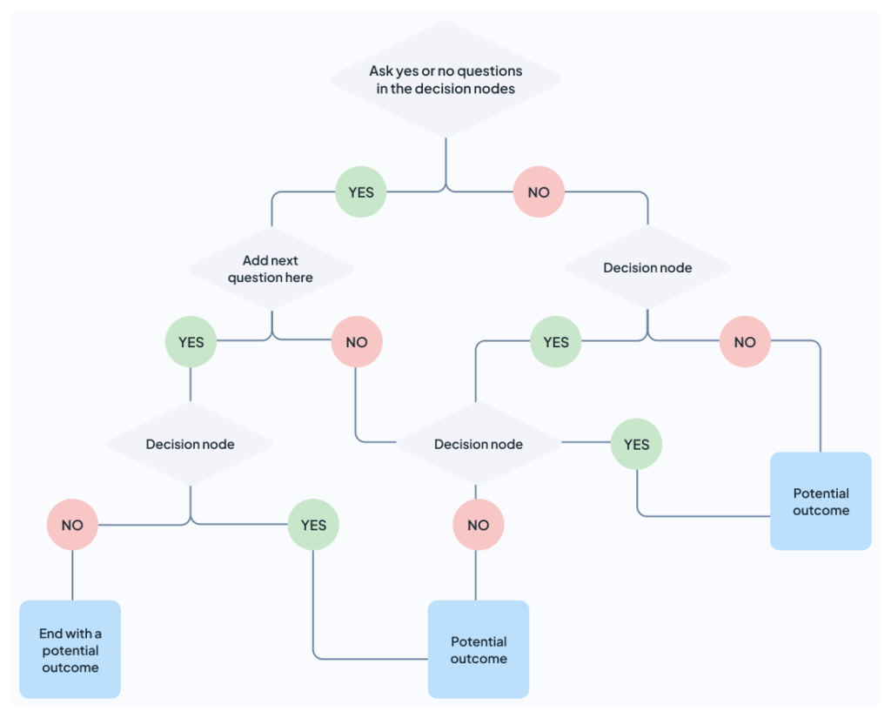

Benefits of Scenario Analysis
Key benefits of scenario analysis include:
- It helps companies manage risks more proactively by assessing the impact of potential future events and situations.
- It can help businesses make better decisions by investigating the risks and benefits of different options.
- The methodical approach to analyzing the future may enable companies to spot opportunities or risks that might otherwise be overlooked.
- It can make communication with stakeholders more productive by using well-defined future scenarios. It also increases the likelihood of gaining support for strategic decisions.
- It improves resource allocation by helping organizations prioritize investments and efforts based on potential future impacts.

Challenges of Scenario Analysis
- Scenario analysis can be a time-consuming process that requires specific skills and expertise, although modeling tools can help.
- It can be difficult to envision all possible scenarios, make realistic assumptions, and assign probabilities to them.
- It can be hard to translate the insights gained from scenario analysis into concrete strategic decisions and actions.

Example Scenario Analysis
The following example shows how a hypothetical small business might follow these six steps to perform a scenario analysis when deciding whether to launch a new product. Consider a small local bakery, “Nicole’s Kitchen,” that is contemplating the addition of a new gluten-free product line.
Step 1: Define the issue and decisions
Nicole’s Kitchen is interested in introducing a line of gluten-free products. The main decisions are whether to launch this new line and how much to invest in it.
Step 2: Gather data and identify key factors
Nicole’s Kitchen puts on its research cap and investigates:
- Local demand for gluten-free products
- Market prices for gluten-free products in the area
- Cost of gluten-free ingredients
- Required equipment investments
- Potential impact on existing product sales
- Competitors’ gluten-free offerings
Step 3: Develop a scenario planning template
Nicole’s Kitchen creates a simple spreadsheet to calculate:
- Projected weekly sales volume of gluten-free products
- Proposed sales prices for each new product
- Projected revenue of gluten-free products
- Costs (ingredients, equipment, additional staff training)
- Overall impact on bakery profits
Step 4: Develop scenarios
Nicole’s Kitchen creates three scenarios:
- Base case: 50 gluten-free items sold per day at $4 each. Gluten-free products account for 15% of sales within 6 months.
- Best case: 80 gluten-free items sold per day at $4.50 each. Gluten-free products account for 25% of sales within 6 months.
- Worst case: 20 gluten-free items sold per day at $3.50 each. Gluten-free products account for only 5% of sales within 6 months.
Step 5: Evaluate the scenarios
Nicole’s Kitchen assesses the scenarios:
- Base case: Profit increase of 10% after 1 year
- Best case: Profit increase of 20% after 1 year
- Worst case: Profit decrease of 5% after 1 year due to unsold inventory and equipment costs
Step 6: Plan accordingly
Based on the analysis, Nicole’s Kitchen decides to:
- Launch a small line of gluten-free products.
- Start with minimal equipment investment.
- Monitor sales closely for the first 3 months.
- Plan to expand the line if sales meet or exceed the base case.
- Prepare a marketing plan to promote the new gluten-free options.

Scenario analysis example #2: Project and Portfolio Management
For example, a global manufacturing company is managing several concurrent projects across its portfolio, including facility upgrades, new product lines, and process optimization initiatives. Each project competes for the same pool of resources, and the budget for the incoming year is limited.
They run scenario analysis to compare different allocation strategies based on key criteria such as potential ROI, strategic alignment and resource constraints. By simulating various combinations of project priorities and staff allocation, they can visualize the impact on their choices on project timelines, resource usage and budget consumption. So, for example:
- In one scenario they decide to prioritize high-ROI projects that can be completed within the fiscal year.
- In a second scenario, they may focus on long-term strategic projects with lower immediate returns but higher alignment with future goals.
In this case, the analysis helps them decide which projects should be accelerated or delayed based on resource availability and budget restrictions. Also, the company can make informed decisions about whether to outsource certain functions or hire temporary staff to handle peak demand periods.

Conclusion
Scenario analysis is undoubtedly one of those tools that no organization can do without. It allows you to make informed decisions based on real data. Whether you’re managing multiple projects, launching new products, or planning for the long term, the key is understanding how different variables will impact your portfolio. That’s the key to keeping your eye on your goals.
Additionally, tools like Triskell Software allow you to perform scenario analysis easily and intuitively, even if you’re managing multiple projects simultaneously. This ensures that your teams are always prepared for whatever comes next, whether it’s a storm or an unexpected opportunity. Because, at the end of the day, the only certainty is that nothing is certain, right?

